Is sitting at your desk all day slowly squashing the life out of your back?
Here is a simple free tool to help you

If you work in an office, the chances are you do not move around enough.

You may find yourself sitting at your desk for hours at a time and this is terrible for your back and your body!

You probably know you should get up and move around, but do you?? Most of us don’t!

Now, we don’t want to complicate our lives but a simple tool is available on the very computer which keeps you transfixed, which can ensure we move!

If you search “thirty minute timer” or “one hour timer” in google, you will find this countdown. It’s free. We call it the “Desk Bound Egg Timer”.

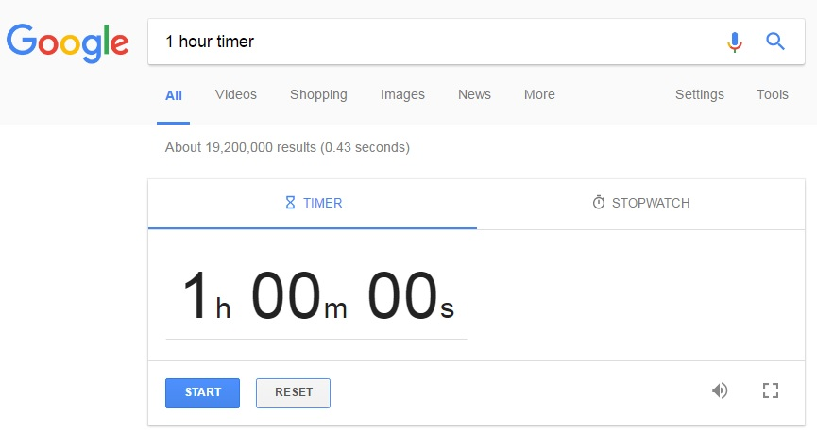

You simply set it and after the allotted time it beeps quietly.

With the sound of the beep, it is not hard to get up, walk up the office, maybe drink some water and then come back.

When you arrive in work, turn on your timer as soon as you turn your computer on. Give it a go and see if it helps you get up from your desk and free your back!

www.iddtherapy.co.uk/desk-bound-egg-timer

